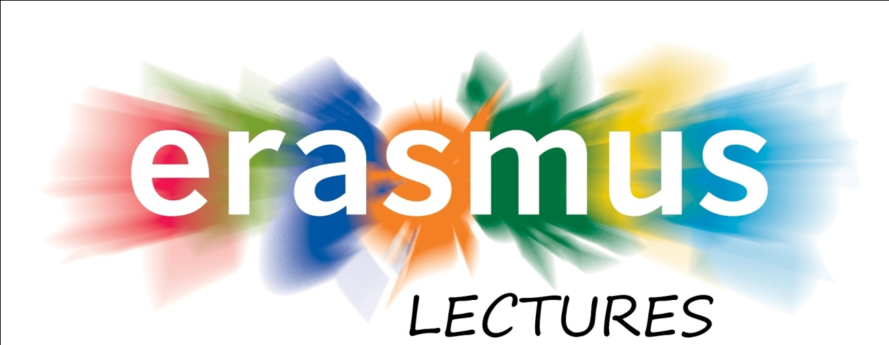
The Erasmus Office cordially invites you to the lectures:
Administrative Procedure in Poland April 20. Mon 15-18 Tanári klub (bldg A)

Lecture concerning administrative procedure in Poland will present basic aspects of administrative procedure, especially regulated in the Code of Administrative Proceedings. This Code is one of the key legal acts in the Polish legal system due to its vast scope of application and the importance of issues governed thereby. The lecture will focus on fundamental problems including history of administrative proceedings, relation between general administrative proceedings and administrative judicial proceedings, chosen aspects of decision making process and appellate proceedings.
Lecture schedule:
- Short history of administrative proceedings in Poland
- Administrative procedural law in the legal system
- Principles of administrative proceedings
- Parties to the proceedings
- The authorities conducting the proceedings
- Fundamental aspects of the proceedings
- Decisions, settlements and orders,
- Appeal and appellate proceedings

Principles of Good Administration April 21. Tuesday 15-18 Gy 208 (building C)
Lecture will present modern standards of functioning administrative authorities in democratic countries in the prospect of European Code of Good Administrative Behavior.
Lecture schedule:
- The right to good administration
- European Code of Good Administrative Behavior
- The public service principles in EU
- The fundamental principles of good administration
- Procedural aspects of good administration principles

by Dr Maciej GAPSKI
visiting professor of
John Paul II Catholic University of Lublin
