
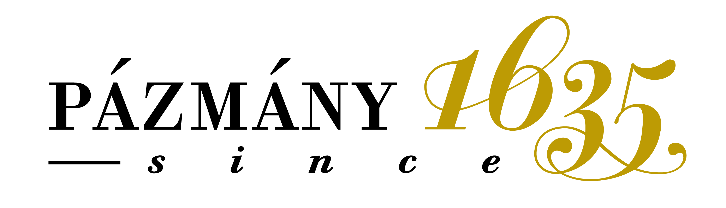
Pázmány Péter Catholic University
Faculty of Law and Political Sciences
Office for Research and International Relations

__________________________________________________________________________________

Academic Calendar of the Faculty of Law and Political Sciences (2023-2024/2/Spring)

On-line Application Form – to be uploaded: | latest by 30 October, 2023
Student’s on-line registration to the NEPTUN system (=selecting term status, course registration is not possible without setting your term status): | 12 February 9:00 - 10:00 am
On-line course registration in NEPTUN System:  (Please register for the courses as soon as possible – as the places are not guaranteed.) | 12 February 09:03-23:59 (changes latest by 8 March noon)
Courses (under 5 participants) are deleted:  (Please check if your registered courses were deleted or not as you can register for another one.) | 6 March, 12:00 – 16:00
On-line course registration if the course was deleted: | 6 March, from 16:00 - latest by 8 March noon
Arrival in Budapest (recommended/not compulsory) | 25-28 February
Orientation Day at the Law Faculty Erasmus Office -Budapest, Szentkirályi street 28 1st Floor, room 138 | 29 February – 10 o’clock
Orientation programs | 29 February - 3 March
Spring semester duration: | 12 February – 25 May  exam period ends:30 June
First day of lectures:  in Spring | 4 March (practical courses: 11 March);
Changing courses: (in well-reasoned cases and only by email! Only staff has access to the system) | until 8 March - noon
Sports day (no classes)  Pázmány day (no classes) | …..  …..
Holidays (no classes) | 15, 28, 29, (30) March; 1, 16 April,  1, 20 May
Eastern break | 28 March - 2 April
Pre-exam period: | 19 April – 7 May
Examination period: | 27 May – 30 June
Exam registration: (only if you have exam date(s) in Neptun) | 13 May from 9:00
Erasmus Students can normally pass all their exams by mid June - sometimes during the last classes, but please consult with each teacher about it at the beginning of the term.
*

To inform the Office via e-mail if all the grades are on Neptun continuously from mid May- mid June. The Transcript of Records can be printed only if all the grades are uploaded to Neptun system!
*

Last visit to the Erasmus Office to receive the Transcript of Records continuously from mid-May till 30 June. Please send an e-mail to the Erasmus e-mail to issue your certificate before coming to the collect it. Grades should be uploaded in Neptun latest by 30 June, afterwards no modifications in the grades are possible.
*

