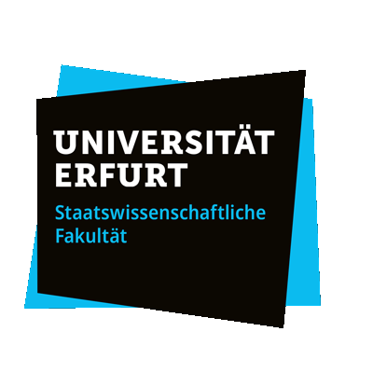

The Lisbon Treaty 15 years on - Achievements and Challenges

Tuesday, March 19th
Welcome coffee
13:00 Introduction
13:10-14:00 Key note by Eleanor Sharpston
14:00-15:30 Panel I: Constitutional Basis of the Multilevel System
- Constitutional Pluralism: In Praise of Political Compromises (Kálmán Pócza / Márton Csapodi)
- Judicial Control Over the Rule of Law and the Necessary Legal Standards (Christina Jacobs / Clarissa Barth)
- EU accession to the ECHR: what’s next? (Vanessa Barbé)
Coffee break
16:00 – 17:30 Panel II: The Union’s Economic and Financial Constitution
- Financial Sovereignty in the European Union (Michael W Müller)
- The resilience of the EMU constitutional framework to crises (Frédéric Allemand)
- If we want State aid to stay as it is, State aid will have to change’. Are the Treaty’s rules on State aid still fit for the age of permacrisis? (Pierfrancesco Mattiolo)

Conference dinner for speakers and panellists

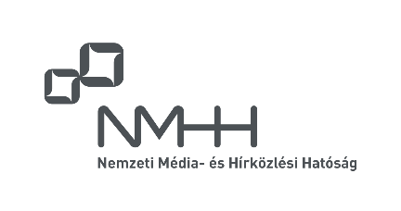

The event is supported by the National Media and Communications Authority.

The Lisbon Treaty 15 years on - Achievements and Challenges

Wednesday, March 20th
9:00 Introduction
9:10-10.00 Key note by Tihamér Toth
10:00-11:30 Panel III: Enforcement of EU Law
- The counter-reformation of comitology (Merijn Chamon)
- Composite Administrative Procedures - the Quiet Revolution in EU Administrative Law (Ieva Huna)
- Inconsistent administrative enforcement of EU law at Member State level (Katarzyna Jancewicz / Pieter Van Cleynenbreugel / Julien Bois)
Lunch break
13:00-14:30 Panel IV: External Action
- Options for further flexibility in the adoption of decisions and in the implementation of operational actions within CFSP under the existing treaty framework (Csaba Törő)
- Giving bite to the bark: To what extent has the Lisbon Treaty allowed restrictive measures to become a fully-fledged EU policy? (Celia Challet / Julien Tribout)
- The Treaty of Lisbon: An impediment to EU’s strategic autonomy? (Christos Karetsos)
Coffee break
15:00-16:30 Panel V: The Union in the Digital Age
- The European Digital Model: From Citizenship to European Digital Identity (Margarita Robles-Carrillo)
- European Integration in the Age of Digitalisation and Artificial Intelligence: Digital European Citizens’ Councils as a Way of Enhancing Supranational Democracy? (Jan Philipp Huth)

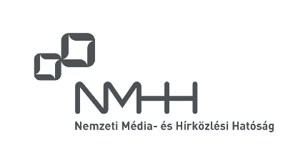

The event is supported by the National Media and Communications Authority.

