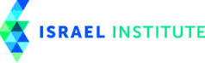

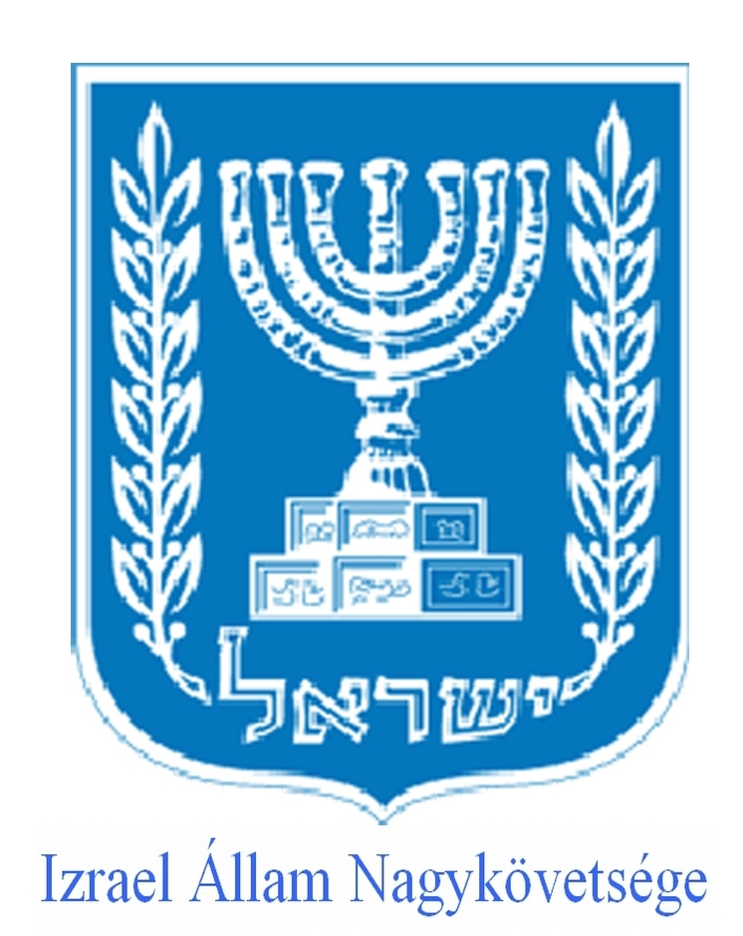

ELTE BTK Spring Semester 2014

MODERN ISRAEL: CONFLICT and DIVERSITY

Location: 1038, Múzeum krt, BTK, Kari Tanácsterem
Dates: 16, 17, 23, 24 February; 23, 24 March; 13, 14 April; 11, 12 May.

Course description:
The new course at ELTE University Budapest aims to present the controversies and cultural political complexity of the state of Israel. The course will be thought by experts from the best universities around the world. On one hand the course will explore the establishment of Jewish political sovereignty based on a variety of sources, on the other hand the internal and international consequences of this act. The course goal is to understand the Zionist movement and the development of the conflict between Zionist settlers and a Palestinian nationalist movement, to analyze the background of Israel criticism providing an understanding of modern nation-building process and the distinctive features of Israeli democracy. The course will attempt to look beyond the peace negotiations.
The course will examine the parallel and conflicting narratives: the contested legitimacy of the state in different political and historical views, traces the causes and consequences of the wars Israel had been involved. The course will reflect on the question of the “final” borders, and the relationship with the neighboring states, with Europe, USA and the world.
During this course Israel will also be studied as a modern state with a dynamic economy with more startups per capital than any other country in the world, that has as much venture capital as the leading West European countries.
While the course will elaborate on the long conflict between Israelis and Palestinians, will also present the internal conflicts: unresolved problems in defining the relationships between Judaism, the Jewish law, Jewish population and the state, between its religious and secular society, and rights and lives between the Jews and non-Jewish minorities. The course will analyze the benefits and challenges of a multi ethnic, vibrant, multicultural society with an endlessly diverse cultural background.

Course Requirements
Attendance and active participation in class. (Missing more than 3 classes will not allow you to take the exam.)
Grading: written short Q and A test like exam on on 11th and 12th of May in English or Hungarian.

The reading materials, links, documents, movies can be found:
a). Ideally in Neptun as e-learning materials,
b). In case Neptun doesn't work (again), join the Facebook group called Israel studies course. Modern Israel: conflict, diversity, and controversy crated by Zsófia Kata Vincze where everything will be posted (and this always works). The group will be closed as a secret group after 25th of February, afterwards no one can see the members or the posts from outside.
c). You will also find the reading materials in a dropbox file

READINGS

(all your reading materials can be found in your virtual library)
- Gat, Azar and Alexander Jakobson: Nations. The Long History and Deep Roots of Political Ethnicity and Nationalism, Cambridge University Press,. 2013.
- Shapira, Anita: Israel – A History, Brandeis University Press, Waltham, 2012.
- Rabinovich, Itamar: The Lingering Conflict. Brookings, 2011. pp 1-26.
- Roth, Ariel Ilan: The Sum of All Fear, Foreign Affairs, 2012.
- Troen, Ilan: Imagining Zion, Yale Univeristy Press, 2003. pp 149 – 159.

Documents to read
- Declaration of Israel's Independence Presented by David Ben-Gurion, Tel Aviv, May 14, 1948(5th of Iyar, 5708).
- The Covenant of the Islamic Resistance Movement (Hamas). 18 August 1988 .
- The Palestinian National Charter: Resolutions of the Palestine National Council, July 1-17. 1968.

COURSE SCHEDULE

1). 16 February 2015, 4 p.m. Location: Gólyavár, Pázmány Péter terem

Zsofia Kata Vincze lecturer at ELTE

“Jewish and Democratic? Introduction to academic studies of Israel”

4.30 prof. Meir Litvak “Islamist Movements and the Arab-Israeli conflict”

2). 17 February, 2015 4. 00. pm prof. Meir Litvak, Tel Aviv University location: Kari Tanácsterem

“Iran and the Arab-Israeli conflict (which will also include a broader discussion on Iran and the region)”

3). 23 and 24 February 2015, 4p.m. Location: Kari Tanácsterem

prof. Itamar Rabinovich, Tel Aviv University, NYU, Ambassador of Israel to United States

"Israel, Palestine and the Arab World"

"The Peace Process and the lingering conflict "

4). 23 and 24 March 2015, 4p.m. Location: Kari Tanácsterem

prof. Ariel Roth Executive director Israel Institute, Washington

"Securing a Homeland Strategic Doctrine and Practice”

"Contemporary Security Challenges"

5). 13 and 14 April 2015, 4 p.m. Location: Kari Tanácsterem

Shimon Stein Ambassador of Israel to Germany
"Strategic issues in the Middle East"
"Israeli-European Relations"

6). 11 and 12 May 2015, 4.pm Location: Kari Tanácsterem Ilan Mor ambassador of Israel to Hungary, Gábor Balázs professor at ORZSE and Zsofia Kata Vincze professors at ELTE

“Israel and religious pluralism”

“Israel and ethnic and social pluralism”

The last two classes will be fallowed by a 25 minute test

BIOS of GUEST PROFESSORS

Itamar Rabinovich

Professor Rabinovich was an Israeli politician and the Israeli ambassador to the United States from 1993 to 1996. He was then the President of Tel Aviv University. He is currently a visiting professor at the Kennedy School of Government at Harvard University. Previously he was Israel's Chief Negotiator with Syria (1992–1995) and a Professor at Large at Cornell University (1997–2002).
Rabinovich received B.A. degree from the Hebrew University of Jerusalem, an M.A. from Tel Aviv University and a Ph.D. from UCLA. He received Commandeur de l'Ordre des Palmes Académiques from France.

Books

Rabinovich, Itamar (1972). Syria under the Baʻth, 1963-66. ISBN 0-7065-1266-9.
Rabinovich, Itamar; Haim Shaked (1978). From June to October. ISBN 0-87855-230-8.
Shaked, Haim; Itamar Rabinovich (1980). The Middle East and the United States. ISBN 0-87855-752-0.
Rabinovich, Itamar (1985). The war for Lebanon, 1970-1985. ISBN 0-8014-9313-7.
Rabinovich, Itamar (1999). The Brink of Peace. ISBN 0-691-01023-4.
Rabinovich, Itamar (2004). Waging peace. ISBN 0-691-11982-1.
Rabinovich, Itamar; Jehuda Reinharz (2008). Israel in the Middle East. ISBN 0-87451-962-4.
Rabinovich, Itamar (2008). The View from Damascus. ISBN 0-85303-800-7.

Meir Litvak
Meir Litvak (Ph.D, Harvard 1991). Associate Professor at the Department of Middle Eastern History, Director of the Alliance Center for Iranian Studies and Senior Research Fellow at the Dayan Center for Middle Eastern Studies at Tel Aviv University, Coordinator of the Parviz and Pouran Nazarian Chair for Modern Iranian Studies. Meir Litvak currently serves as an associate professor in the Department of Middle Eastern History and as the director of the Alliance Center for Iranian Studies at Tel Aviv University. Dr. Litvak has written numerous articles and books on modern Shi‘a and Iranian history, as well as on modern Islamic movements. He is the author of Shi'a Scholars of Nineteenth Century Iraq: The ‘Ulama’ of Najaf and Karbala’ (Cambridge University Press, 1998); and co-author of From Empathy to Denial: Arab Responses to the Holocaust (Columbia University Press, 2009) and of the forthcoming book Iran: from a Persian Empire to an Islamic Republic (Open University of Israel Press). In addition, he is the co-editor of Religious Fanaticism (Zalman Shazar Center, 2007); Palestinian Collective Memory and National Identity (Palgrave-McMillan); and The Sunna and Shi‘a in History Division and Ecumenism in Islam (Palgrave-McMillan, 2011). Dr. Litvak received his doctorate from Harvard University in 1991.

Ariel Ilan Roth
Ariel Ilan Roth is Executive Director of the Israel Institute in Washington. He previously served as Director of the Global Security Studies graduate program at Johns Hopkins University.
He regularly teaches courses in military strategy and modern war for the Government program at Johns Hopkins, and his interests include Israeli strategic studies, U.S. foreign and defense policy and international relations theory. Ariel is an occasional commentator on foreign policy and security-related topics for both national and international newspapers.
He is the author of Leadership in International Relations (2010), which examines the role of leaders in creating an effective balance of power, and articles in professional academic journals. He is a fellow at the Johns Hopkins Center for Advanced Governmental Studies and a veteran of the Israeli military. Ariel earned a B.A. from the Hebrew University and a Ph.D. from Johns Hopkins University.

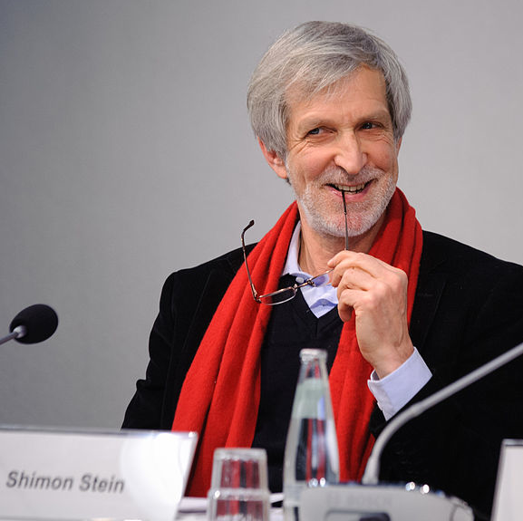
Shimon Stein
Ambassador Stein was a Israeli ambassador to Germany; former minister and director for the Department of Arms Control and Disarmament for the Ministry of Foreign Affairs in Jerusalem. Ambassador Stein s previous roles include service as a councilor for political affairs at the Israeli Embassy in Bonn and a senior analyst at the Centre for Political Research. He was also deputy director for the Office of the State Secretary for the Ministry of Foreign Affairs and later minister-counselor for political affairs for the Embassy of Israel in Washington, D.C. Ambassador Stein was minister and director for the Department of Arms Control and Disarmament for the Ministry of Foreign Affairs in Jerusalem. He served as deputy state secretary and director of the division for the Commonwealth of Independent States and Central and Eastern Europe Department for the Ministry of Foreign Affairs in Jerusalem.
In 2006 Stein called on the German government to stop Iranian president Mahmoud Ahmadinejad from visiting the FIFA World Cup. He accused the Syrian government of providing weapons to Hezbollah after the 2006 Lebanon War. During a 2007 pilgrimage to Israel by 27 Roman Catholic bishops from Germany, two bishops compared the plight of Palestinians in the West Bank to that of Jews in the Warsaw Ghetto during the Second World War, to which Stein said, "If one uses terms like Warsaw Ghetto or racism in connection with Israeli or Palestinian politics, then one has forgotten everything, or learned nothing". Regarding Germany's relations with Iran and Iran's nuclear program, he said in 2008 Germany needed to reduce trade with Iran even further. He says Iran is a threat not only to Israel but to "so-called moderate Sunni and pro-Western regimes". He said in 2010 of the disparity between government support and popular criticism of Israel in Germany: "This worries me because in democracies, political parties seek public approval for their policies. In the long run, the discrepancy is not good for us or for our friends in Germany." In 2006 he said antisemitism was increasing in Germany.

